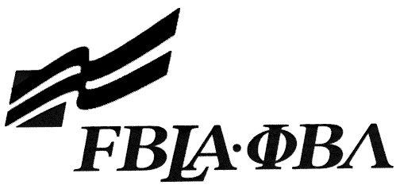 PBL Statement of Assurance

This form must be completed and emailed to KY PBL Adviser, Kelley Walker, kelleywalker617@gmail.com.

Check one: ☐ Mobile Application Development
☐ Website Design

Provide a complete URL for your event. This event will be judged online. Make sure the URL link is valid through the State Leadership Conference.

State: |  |  | ☐ PBL
School:
Website URL Address: (where appropriate)
Member(s) Name:
Local Chapter Contact
Name:
Daytime/Cell Number:
E-mail:

I/We, the undersigned, attest that the design, creation, and implementation of the event are the original work of the above chapter member(s). I/we agree that this event may be linked, promoted, and used in any way by the national FBLA-PBL, Inc. for purposes of promoting the association. (Typed name is accepted for signature)
Name of Team Member |  | Adviser’s Name
Name of Team Member |  | Name of Team Member
Complete this Document Section for All Appropriate Events:
Software Used:
Source of Information:
Copyright Notations:
Instructions for Running Project:
Template(s) Used (source):

